CMIS 102 Hands-On Lab

Week 3 Overview
This hands-on lab allows you to follow and experiment with the critical steps of developing a program including the program description, analysis, test plan, design, pseudocode visualization, and implementation with C code. The example provided uses mathematical operators and variable types.

Program Description
This program will calculate the area of a right triangle. The program will ask the user to enter the base and height and then use these values to calculate and then print the area of the triangle. The design step will include pseudocode.

Analysis
I will use sequential programming statements.
I will define two float numbers for the base and height: base, height.
Float numbers were selected as opposed to integers to make sure triangles of all dimensions are possible and not just whole numbers. Float number will store the area: area The area will be calculated by this formula:
Area = ½ * (base * height)
For example if the base was 4.2 and the height was 5.3 the area would be calculated as:
Area = ½ * (4.2 * 5.3) = ½ * (22.26) = 11.13

Test Plan
To verify this program is working properly the following base and height values could be used for testing:
Test Case | Input | Expected Output
1 | Base=10.1 Height = 12.2 | Area = 61.61
2 | Base=2.67 Height = 3.23 | Area = 4.31
3 | Base=100.0 Height = 400.0 | Area =20000.0

Pseudocode
// This program will calculate the area of a right triangle.
// Declare variables
Declare base, height, area as Float

// Ask User for Inputs Write “Enter triangle base:”
Input base
Write “Enter triangle height:” Input height
// Set value of area
Set area=1/2*(base * height)
// Print area
Print “Area of triangle is “ + area

Code
The following is the C Code that will compile in execute in the online compilers.
// C code
// This program will calculate the area of a right triangle.
// Developer: Faculty CMIS102
// Date: Jan 31, XXXX #include <stdio.h>
int main ()
{
/* variable definition: */ float base, height, area; /* Prompt user for base */
printf("Enter the base of the triangle: \n");
// Input the base scanf("%f", &base); /* Prompt user for height */
printf("Enter the height of the triangle: \n");
// Input the base scanf("%f", &height); // Calculate the Area area= 0.5 * (base * height); // Print the result printf("Area is : %f\n", area); return 0;
}

Setting up the code and the input parameters in ideone.com:
Note the base and height (10.1 and 12.2) are entered in the enter input (stdin) field. You can change these values to any valid float values to match your test cases.

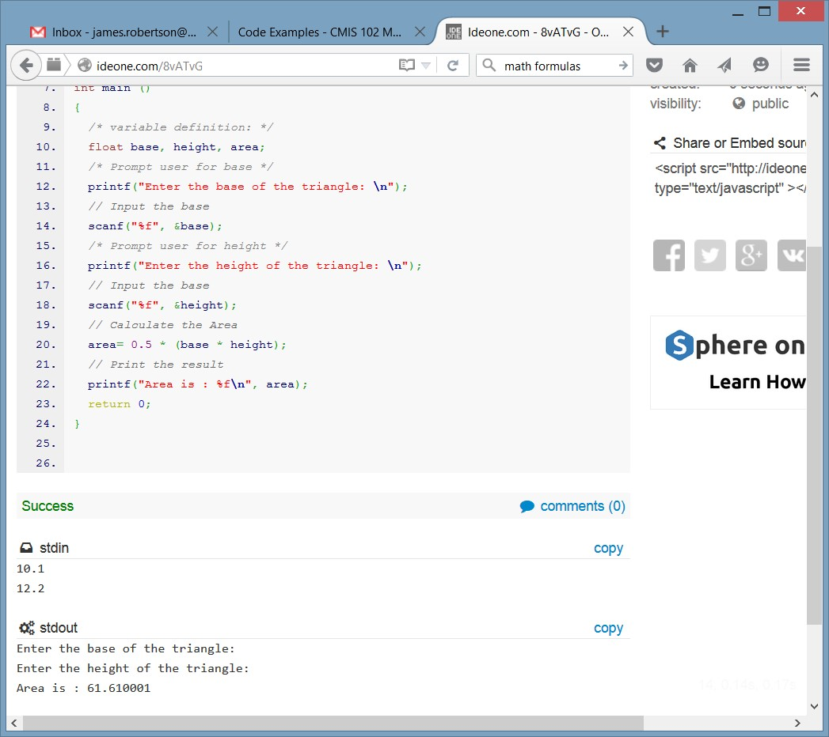

Learning Exercises for you to complete
- Demonstrate you successfully followed the steps in this lab by preparing screen captures of you running the lab as specified in the Instructions above.

- Change the C code to calculate the perimeter of a triangle. Support your experimentation with a screen capture of executing the new code

- Prepare a new test table with at least 3 distinct test cases listing input and expected output for the perimeter of a triangle.

- What is this line of code doing?

scanf("%f", &height);

How would you change this line if you wanted to input an Integer as opposed to a float?

- What are the values of f and g after executing the following C?
#include <stdio.h>
int main(void) { int i,j; float f,g;

i = 5; j = 2; f = 3.0; f = f + j / i; g = (f + j )/i;
printf("value of f,g is %f,%f\n", f,g); return 0;
}

Describe specifically, and in your own words, why are the values of f and g different? Support your experimentation with a screen capture of executing the code.

Submission
Submit a neatly organized word (or PDF) document that demonstrates you successfully executed this lab on your machine using an online compiler. You should provide a screen capture of the resulting output.
Also, provide the answers, associated screen captures, C Code and descriptions of your successful completion of learning exercises 1, 2, 3 and 4.
The answers to the learning exercises, screen captures, C code and descriptions can be included in the same neatly organized document you prepared as you ran this lab. Note the code can be embedded in the word document. However; be sure all code compiles and runs perfectly before submitting the document.
Submit your document no later than the due date listed in the syllabus or calendar.

Grading guidelines
Submission | Points
Demonstrates the successful execution of this Lab within an online compiler. Provides supporting screen captures. | 3
Provides a new test table with at least 3 distinct test cases listing input and expected output for the perimeter of a triangle. | 2
Accurately describes the purpose of the scanf code. Accurately describes how to modify the code to input an integer as opposed to a float. | 2
Accurately describe why are the values of f and g different for the provided code? Supports your experimentation with screen captures of executing the code. | 2
Document is well-organized, and contains minimal spelling and grammatical errors. | 1
Total | 10

